# VISUALIZING AND PREDICTING HEART DISEASES WITH AN INTERACTIVE DASHBOARD

**TEAM ID:**PNT2022TNDID45965

**TEAM LEADER** : HARTINA PRIYADHARSHINI. G

**TEAM MEMBER 1** : JANANI.P

**TEAM MEMBER 2** : SANTHOSH.R

**TEAM MEMBER 3** : SANTHOSH KUMAR.S

**PROBLEM DEFINITON:**

Heart related diseases or Cardio Vascular Diseases (CVDs) are the main reason for a huge number of deaths in the world over the last few decades and has emerged as the most life-threatening disease, not only in India but in the whole world. Many researchers, in recent times, have been using several machine learning techniques to help the health care industry and the professionals in the diagnosis of heart related diseases. This indicates a need of reliable, accurate and feasible system to continuously monitor and diagnose for CVD for timely action and treatment. This work proposes a smartphone-based heart disease prediction system than can have both monitoring as well as prediction of heart disease. A system to monitor patients in real-time has been developed using Node MCU interfaced with temperature, humidity and pulse rate sensors. The developed system is capable to transmit the acquired sensor data to a cloud(firebase) every 10 seconds. An Android application is designed to display the sensor data.

One best machine learning algorithm was ported to the Android application for heart disease prediction in real-time. The machine learning algorithms were trained and tested using two widely used open-access datasets. Five machine learning algorithms were checked for their performances using two different methods. ANN was found to be the best performing algorithm with an accuracy of 93.5%. This algorithm is deployed to the Android application and the heart disease is predicted in real-time. The proposed work is limited by use of single hidden layer for implementing Neural network. Data from few more sensors related to heart parameters should be experimented with. Trying out with increasing hidden layer size may increase the accuracy of the neural network. There is further scope in optimizing the Android application user interface.

**Technical Architecture:**

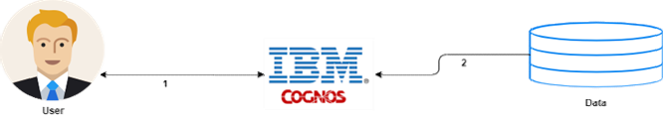

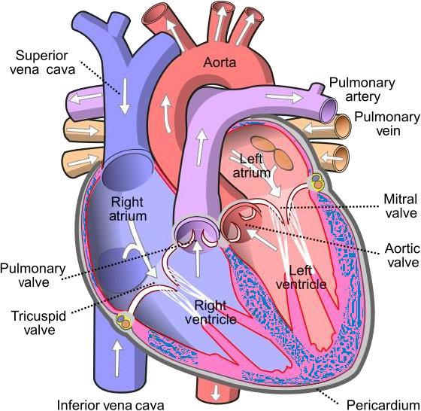

# How to preprocess data in Python:

Here we are using Jupyter Notebook, we imported the libraries. The main way to import a program in library functions are used in Pandas, Numpy, OS Matplotlib, Seaborn, and sklearn. Pandas is a library that creates dataframes and manipulates them. Numpy is a library that works on arrays and performs algebraic functions. OS is a library that allows the retrieval of the files in the working directory, and sklearn is a popular library used for machine learning. Matplotlib and Seaborn are graphic libraries that enable the visualization of data.

# PAPER 1

**Published In**: International Research Journal of Engineering and Technology

**Date of Conference**: 07/05/2020

**Print ISSN**: 2395-0072

**Proposed Model**: Predicting the Risk of Heart Failure With EHR Sequential Data Modeling

**Proposed By**: Bo Jin, Chao Che et al. **IEEE Accession Year**: 2018 **Conference Location**: China

### Data analysis using IBM Congnos Analytics and IBM cloud

**Data analysis**, is a process for obtaining raw data, and subsequently converting it into information useful for decision-making by users. Data is collected and analyzed to answer questions, test hypotheses, or disprove theories.

Statistician **John Tukey**, defined data analysis in 1961, as:

"Procedures for analyzing data, techniques for interpreting the results of such procedures, ways of planning the gathering of data to make its analysis easier, more precise or more accurate, and all the machinery and results of (mathematical) statistics which apply to analyzing data."

There are several phases that can be distinguished, described below. The phases are iterative, in that feedback from later phases may result in additional work in earlier phases. The **CRISP framework**, used in data mining, has similar steps.

**IBM Cognos Business Intelligence** is a web-based integrated business intelligence suite by IBM. It provides a toolset for reporting, analytics, score carding, and monitoring of events and metrics. The software consists of several components designed to meet the different information requirements in a company. IBM Cognos has components such as IBM Cognos Framework Manager, IBM Cognos Cube Designer, IBM Cognos Transformer.

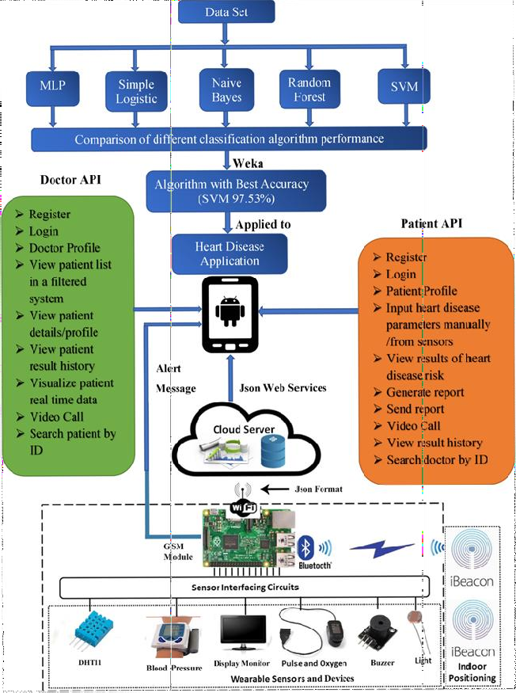

# PAPER 2

**Published In**: International Research Journal of Engineering and Technology

**Date of Conference**: 07/05/2020

**Print ISSN**: 2395-0072

**Proposed Model**: Effective Heart Disease Prediction Using Hybrid Machine Learning Techniques

**Proposed By**: Senthilkumar Mohan, Chandrasegar Thirumalai and Gautam Srivastava

**IEEE Accession Year**: 2019

**Conference Location**: India

### Data Visualization for Health care

Data visualization in the healthcare industry is no longer an option— it’s a must-have for modern medical organizations. The global market of **healthcare data analytics** is estimated to grow **3.5 times** in just six years, from $11.5 billion in 2019 to $40.8 billion in 2025. Meanwhile, more than halfof the healthcare organizations worldwide name data integration as the first technology they plan to adopt by the end of 2021.

While many factors influence the boom in data analytics and visualization tools, the most recent and obvious one is the pandemic. The COVID-19 outbreak drove the health tech adoption, which naturally increased the volumes of data available in digital format. To bring relevant information into focus, healthcare organizations implement tools for data integration and visualization.

Interactive maps, sites, or widgets allow users to choose how they interact with the data and focus on what's relevant. For example, the Institute for Health Metrics and Evaluation offers an interactive websiteto analyze death rates and leading death causes worldwide. There, you can switch between maps and charts or choose a specific country, age, or gender group.

Healthcare data visualization tools allow everyone to view simplified information at a glance, resulting in better understanding and higher engagement, regardless of whether your audience is stakeholders or patients

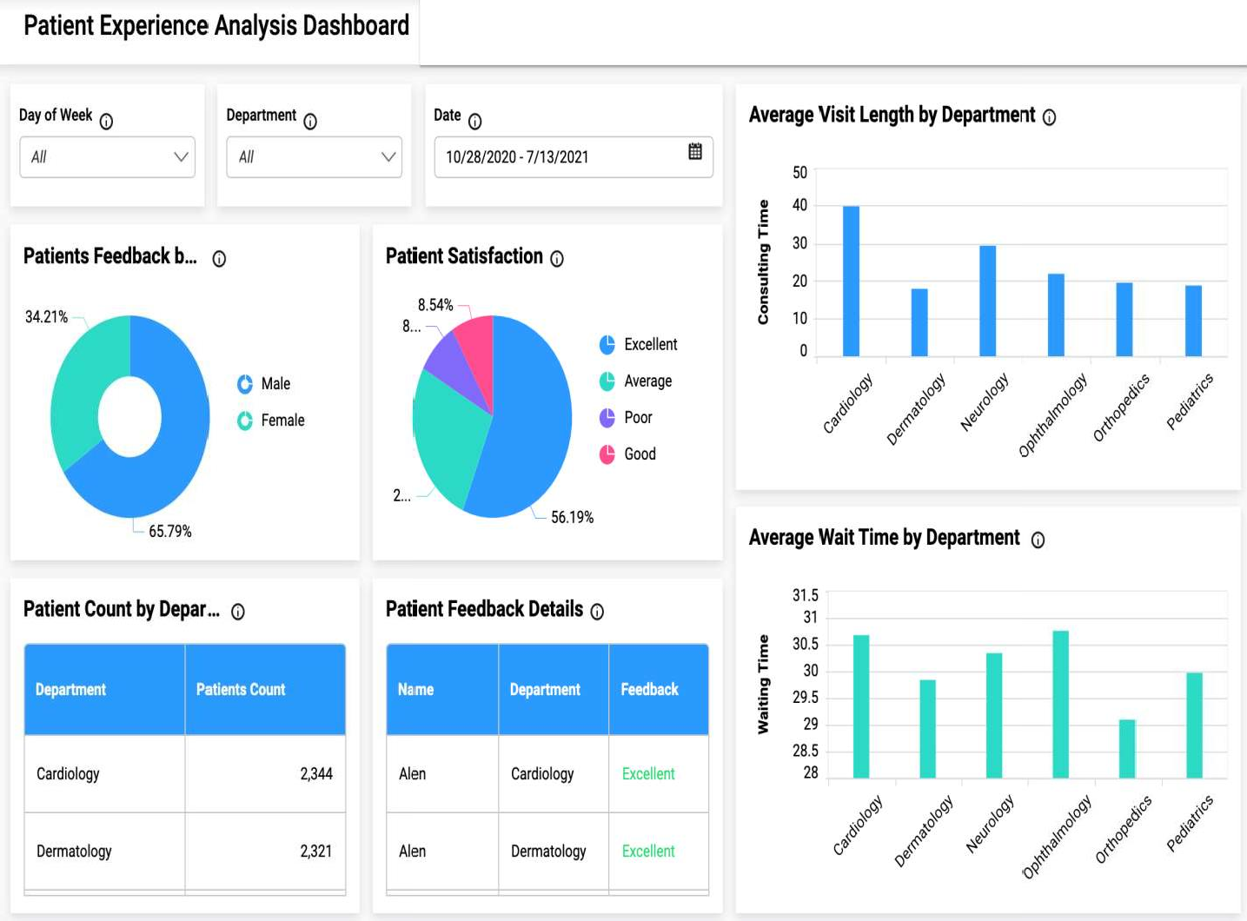

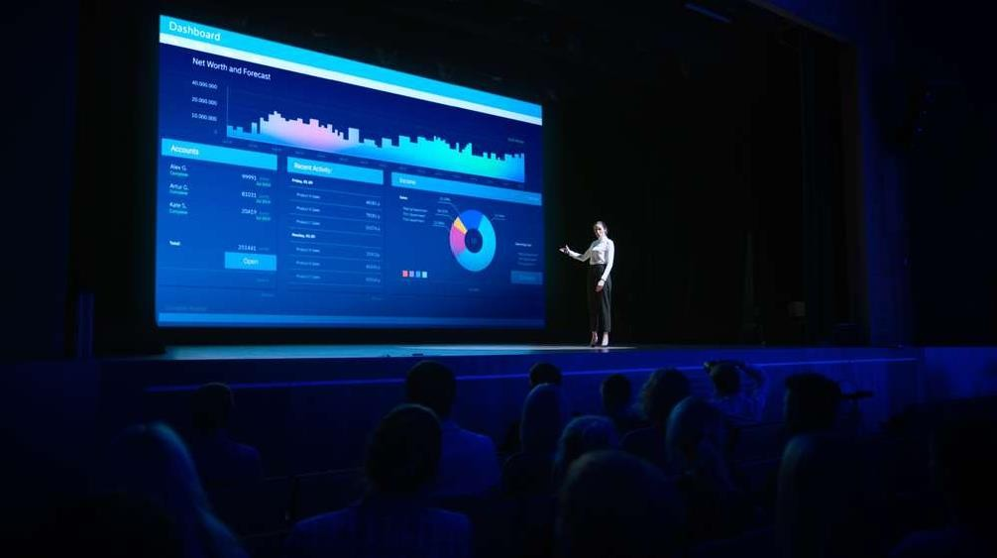

# PAPER 3

## **Published in:** 2021 Second International Conference on Electronics and Sustainable Communication Systems (ICESC)

**Date of Conference:** 04-06 August 2021

**Date Added to IEEE Xplore:** 23 September 2021

**INSPEC Accession Number:** 21224734

## **DOI:** 10.1109/ICESC51422.2021.9532790

**Publisher:** IEEE

**Conference Location:** Coimbatore, India

**Electronic ISBN:** 978-1-6654-2867-5

**MACHINE LEARNING**

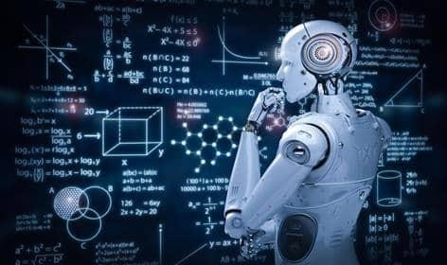

# Heart Diseases Prediction with Machine learning

**Artificial Intelligence** can enable the computer to think. Computer is made much more intelligent by AI. Machine learning is the subfield of

AI study. Various researchers think that without learning, cannot be developed.

**Machine learning (ML)** is causing quite the buzz in t

h

intelligence

e healthcare

industry as a whole. Payers to healthcare companies around the world are taking advantage of ML today. In this post, I will demonstrate a use case and show how we can harness the power of ML and apply it real world problems. We’ll walk through a very simple baseline model for

a

predicting heart disease make some predictions.

from patient data, how to load the data, and

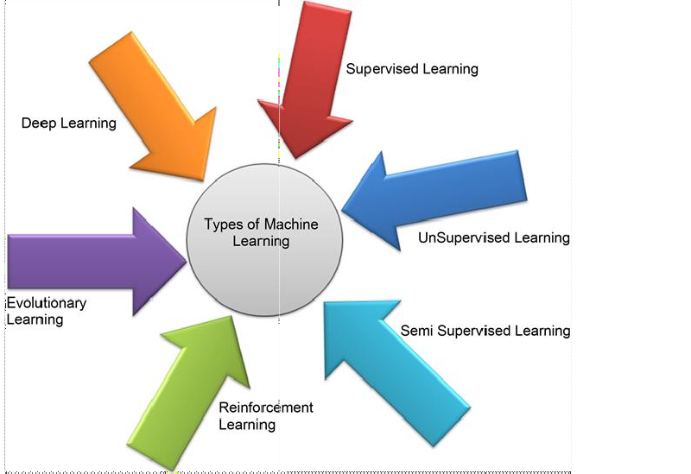

**Diagnosis of Diseases by Using Different Machine Learning Algorithms**

# Heart Disease

Coronary artery disease is detected and monitored by this proposed system. Cleveland heart data set is taken from UCI. This data set consists of 303 cases and 76 attributes/features. 13 features are used out

e

of 76 features. Two tests with three algorithms Bayes vector machine, and Functional Trees FT are performed purpose. WEKA tool is used for detection.

Net, Support for detection

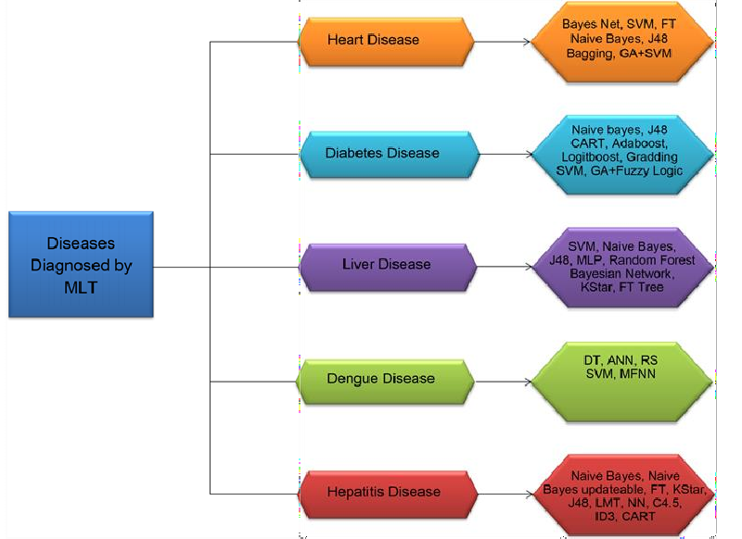

# CRITICAL FINDING:

The below mentioned link is to show the existing solution of predicting heart diseases

* https://[www.readmyecg.co/](http://www.readmyecg.co/)
* https://[www.fitbit.com/global/us/technology/health-metrics](http://www.fitbit.com/global/us/technology/health-metrics)